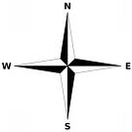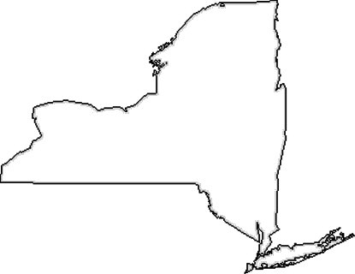

**Key**

Mountains

Hills

Plateaus

Plains

Rivers

Lakes

Ocean

Name:__________________________________________________________________________________ # ____________________